

**Software Requirements**

**Specification**

**for**

**Online Course Reservation System**

**Version 2.0 approved**

**Prepared by :**

**Rakshitha K – 22BD1A660U**

**Nethaji A – 22BD1A6604**

**Sree Hari Smitha K – 22BD1A660L**

**Sai Sharan D – 22BD1A660E**

**Srija M– 22BD1A660Z**

**Keshav Memorial Institute of Technology**

**25-10-2024**

**Table of Contents**

**1. Introduction………………………………………………………1**

1.1 Purpose………………………………………………………………..1

1.2 Document Conventions……………………………………………….1

1.3 Intended Audience and Reading Suggestions………………………...1

1.4 Product Scope…………………………………………………………2

1.5 References…………………………………………………………….2

**2. Overall description………………………………………………..3**

2.1 Product Perspective……………………………………………………3

2.2 Product Functions……………………………………………………...3

2.3 Operating Environment……………………………..............................3

2.4 User Characteristics…………………………………………………....3

2.5 Design and Implementation Constraints……………………………....4

2.6 User documentation……………………………………………………4

2.7 Assumptions and Dependencies……………………………………….4

**3. Specific Requirements……………………………………………5**

3.1 User Interfaces…………………………………………………………5

3.2 Hardware Interfaces …………………………………………………...5

3.3 Software Interfaces……………………………………………………..5

3.4 Communications Interfaces………………………………………….....5

**4. System Features……………………………………………………6**

4.1 Patient Registration and Admission……………………………………6

4.2 Doctor Consultation and Scheduling…………………………………...6

4.3 Medical Records Management…………………………………………7

4.4 Billing and Financial Management…………………………………….7

4.5 Staff and Role Management…………………………………………....8

4.6 Patient Self-Service and Report Access………………………………..8

4.7 Pharmacy and Inventory……………………………………………….9

4.8 Reporting and Analystics……………………………………………....9

**5. Non-functional Requirements……………………………………..10**

5.1 Performance Requirements .....................................................................10

5.2 Safety Requirements ...............................................................................10

5.3 Security Requirements ............................................................................10

5.4 Software Quality Attributes ....................................................................10

5.5 Business Rules ........................................................................................11

**6. Other Requirements…………………………………………….....12**

6.1 Regulatory Compliance ..........................................................................12

6.2 Data Backup and Recovery.....................................................................12

6.3 User Accessibility....................................................................................12

6.4 Localization and Internationalization......................................................12

6.5 Scalability................................................................................................12

6.6 Session Management...............................................................................13

Appendix A: Glossary………………………………….....................................13

Appendix B: Analysis Models…………………………………………………...13

Appendix C: To Be Determined List………………………………………….....24

**Revision History**

| **Name** | **Date** | **Reasons for Changes** | **Version** |
| --- | --- | --- | --- |
| Week-1 | 26-09-2024 | SRS Template | 1.0 |
| Week -2 | 18-10-2024 | SRS ( DIAGRAMS) | 2.0 |
| Week -3 | 25-10-2024 | SRS Final Document | 3.0 |

**1.Introduction**

**1.1 Purpose**

The purpose of this product is to bring together all the hospitals, doctors, staffs, patients and other respective parties related to medical care under a single system to facilitate interlinking between different parties and to facilitate more efficient and effective service to consumers. The application aims to maintain a global database of all parties to provide better service. The application is being developed taking into consideration the consumers who through this system will have more options to access and hospitals who can manage their daily needs efficiently.

**1.2 Document Convention**

Heading:

Font-Size:16

Font-Style: Bold

Font: Times New Roman

Subheading:

Font-Size:14

Font-Style: Bold

Font: Times New Roman

Content:

Font-Size:12

Font: Times New Roman.

**1.3 Intended Audience and Reading Suggestions**

This document is intended for multiple stakeholders, each with a specific focus. Developers should concentrate on the functional and non-functional requirements, as well as the system architecture, to effectively design and implement the Hospital Management System (HMS). These sections provide detailed information on how the system is expected to operate and the performance criteria it must meet. Projectmanagers are advised to review sections on project timelines, resource allocation, risks, and costs to ensure that the system is developed on schedule and within budget, while also managing risks effectively. Healthcareadministrators will benefit from understanding how the HMS automates key workflows, improves patient management, and enhances operational efficiency across departments, helping to streamline day-to-day hospital functions. Advertisers**/**marketers should focus on the HMS's unique features, such as seamless integration of multiple hospital services, enhanced patient care, and streamlined operations, which can be used to position the system as a superior solution in the healthcare market. Additionally, **testers** can use this document to identify functional and non-functional testing criteria, ensuring the system meets the necessary quality and performance standards.

**1.4 Product Scope**

The scope of the application is as follows:

The Hospital Management System (HMS) will offer a centralized platform to manage hospital operations and maintain a global database of all relevant healthcare parties. The system will provide access to this database, allowing users to choose and manage services. Key features include a login interface for users to access services and make decisions based on available data, and admin access for maintaining and modifying the database. This integrated solution will streamline patient management, doctor scheduling, billing, and reporting while ensuring secure access to sensitive information.

**1.5 References**

* HL7 (Health Level 7), HIPAA compliance, and ISO 13485 for medical systems.
* MySQL/PostgreSQL documentation, API guides for third-party integration, and software framework manuals (React, Spring Boot).
* Existing system design documents and market research on hospital management systems.
* National healthcare regulations, GDPR, and other data protection laws.

**2.Overall Description**

**2.1 Product Perspective**

The Hospital Management System (HMS) is a centralized, integrated solution aimed at automating hospital operations and streamlining workflows across all departments. It addresses the challenges posed by standalone modules that cause inefficiencies, data duplication, and communication gaps. HMS is designed to interconnect various hospital functions such as patient registration, doctor consultations, staff management, and billing into a unified system. This facilitates better coordination and timely access to relevant data, improving patient care, administrative efficiency, and financial accuracy.

**2.2 Product Functions**

* **Patient Management**: Registers patients, stores personal and medical records securely.
* **Doctor and Staff Scheduling**: Automates scheduling for doctors and staff, ensuring optimal resource allocation and reduced waiting times.
* **Medical Records Management**: Stores, updates, and manages patients' medical histories, accessible only to authorized personnel.
* **Billing and Payments**: Tracks and updates patient financial transactions in real-time, maintaining accurate billing records.
* **Patient Portal**: Allows patients controlled access to their medical reports and bills while maintaining data privacy and security.
* **Reporting and Analytics**: Provides real-time data for decision-making, offering reports on hospital operations, financials, and patient care.

**2.3 Operating Environment**

The Hospital Management System (HMS) will operate in various environments, requiring standard hardware such as desktops, tablets, and smartphones for users including doctors, staff, and patients to access the system. It will be compatible with standard web browsers like Chrome and Firefox and offer mobile-friendly interfaces for patient interactions. A reliable internet connection is essential for real-time interaction and seamless operation between hospital staff and patients. The system's data will be securely stored in a cloud-based environment, ensuring scalability, data recovery, and secure management of sensitive hospital and patient information.

**2.4 User Characteristics**

* **Doctors**: Access medical records, schedule appointments, and update patient information.
* **Hospital Staff**: Handle administrative tasks, manage patient admissions, and coordinate billing and payments.
* **Patients**: View and download medical reports, check billing details, and update personal information through the patient portal.
* **Hospital Administrators**: Oversee the system’s overall performance, generate reports, and manage hospital operations.

**2.5 Design and Implementation Constraints**

The Hospital Management System (HMS) must meet several important requirements. It must ensure data security by following healthcare rules like HIPAA to protect patient information. The system needs to grow as the hospital grows, handling more patients, staff, and departments. It should also update records, financial data, and doctor schedules in real-time for smooth daily operations. Lastly, different users will have different access levels to keep sensitive information safe and confidential.

**2.6 User documentation**

The user documentation for the Hospital Management System (HMS) will include several helpful guides. There will be user manuals for hospital staff, doctors, and administrators, explaining how to use the system’s features. Training guides will be provided to help hospital staff learn how to manage tasks like scheduling, billing, and patient management. Additionally, a patient portal guide will be available to help patients understand how to access and download their medical reports easily.

**2.7 Assumptions and Dependencies**

The development and operation of the Hospital Management System (HMS) depend on several assumptions. It is assumed that hospital staff and patients will receive proper training to use the system effectively, and that stable internet connectivity will be available for real-time access. The system will comply with healthcare standards for data security, and it will be hosted on reliable cloud infrastructure to ensure uptime, scalability, and data recovery in case of system failure.

**3.External Interface Requirements**

**3.1 User Interfaces**

The system will feature user-friendly login screens with an interactive GUI, incorporating intuitive icons, buttons, and clear fonts for an enhanced user experience. When accessing the database, information will be displayed in a well-organized, tabulated format for easy readability.

**3.2 Hardware Interfaces**

The HMS will be compatible with Windows, Mac, and Linux personal computers and laptops, requiring a minimum of a 1.7 GHz processor (13 or above) and at least 2 GB of RAM. Standard hardware peripherals, such as monitors and mouse/touch input devices, will be supported.

**3.3 Software Interfaces**

The system will be developed using Java and will operate on a Unix platform (version 2.6, 32-642.11.1.e16.centos.plus.x86_64). Development tools will include GUI design tools and other open-source software, with NetBeans as the primary IDE for Java GUI development. The database will utilize MySQL and will integrate with services like Dropbox, Google Wallet, Paytm, and other SQL-based applications for data sharing and financial transactions.

**3.4 Communication Interfaces**

The system will utilize Internet protocols such as FTP and HTTP for downloading medical reports and bills, as well as for sending updates made to the database to a global server. No specific browser is required, as the application will directly use the network connection to facilitate data downloads, mimicking browser functionality

**4. System Features**

**4.1 Patient Registration and Admission**

**4.1.1. Description and Priority**

This feature allows hospital staff to register new patients and manage their admission details. It captures essential information such as personal details, medical history, and contact information, and securely stores them. This feature has a **High Priority**, as it forms the foundation for managing patient care throughout the hospital.

**4.1.2. Stimulus/Response Sequences**

* **Stimulus**: A hospital staff member inputs a new patient's details for registration.
* **Response**: The system stores the patient information, assigns a unique patient ID, and displays confirmation of successful registration.

**4.1.3. Functional Requirements**

* REQ-1: The system must generate a unique patient ID for each new patient.
* REQ-2: The system should allow hospital staff to add, view, update, or delete patient records.
* REQ-3: The system must validate patient details, ensuring no duplications and data accuracy.

**4.2 Doctor Consultation and Scheduling**

**4.2.1. Description and Priority**

This feature enables patients and hospital staff to schedule doctor consultations, ensuring real-time synchronization of doctor availability. It simplifies appointment scheduling, rescheduling, and cancellations. This is a **High Priority** feature to streamline patient care and avoid scheduling conflicts.

**4.2.2. Stimulus/Response Sequences**

* **Stimulus**: A patient or hospital staff requests an appointment with a doctor.
* **Response**: The system checks doctor availability, schedules the appointment, and notifies both the patient and the doctor.

**4.2.3. Functional Requirements**

* REQ-4: The system must display real-time availability for all doctors.
* REQ-5: The system should allow the rescheduling and cancellation of appointments.
* REQ-6: The system must send notifications (via SMS or email) to patients and doctors when appointments are scheduled, rescheduled, or cancelled.

**4.3 Medical Records Management**

**4.3.1. Description and Priority**

This feature stores and manages patient medical records, providing authorized personnel with access to accurate and up-to-date information for clinical decision-making. **High Priority** due to the importance of maintaining patient safety and continuity of care.

**4.3.2. Stimulus/Response Sequences**

* **Stimulus**: A doctor or authorized staff requests access to a patient's medical records.
* **Response**: The system retrieves the relevant patient data and displays it for the requested purpose.

**4.3.3. Functional Requirements**

* REQ-7: The system must allow authorized users to access, update, and delete patient medical records.
* REQ-8: The system should maintain a detailed audit trail of any modifications made to medical records.
* REQ-9: The system must ensure secure access to medical records using encryption and role-based permissions.

**4.4 Billing and Financial Management**

**4.4.1. Description and Priority**

The billing and financial management module generates invoices for patient services and tracks payments. It helps ensure accurate billing and smooth financial operations. This is a **High Priority** feature for both hospital administration and patient financial transparency.

**4.4.2. Stimulus/Response Sequences**

* **Stimulus**: Hospital services are rendered (e.g., doctor consultations, treatments, medications).
* **Response**: The system generates an invoice based on the services provided, updates the patient's financial record, and tracks payments.

**4.4.3. Functional Requirements**

* REQ-10: The system must automatically generate an invoice based on the services rendered.
* REQ-11: The system should support multiple payment methods (cash, card, insurance claims).
* REQ-12: The system must generate financial reports for hospital administrators, detailing transactions and outstanding balances.

**4.5 Staff and Role Management**

**4.5.1. Description and Priority**

This feature allows hospital administrators to manage staff information, roles, and work schedules. It ensures smooth operations by allowing quick updates to personnel data. **Medium Priority** for managing the hospital workforce.

**4.5.2. Stimulus/Response Sequences**

* **Stimulus**: Hospital admin enters new staff details or updates existing staff schedules.
* **Response**: The system updates the staff's roles, schedules, and personal details in the database.

**4.5.3. Functional Requirements**

* REQ-13: The system must maintain detailed records for all hospital staff, including roles, work hours, and shifts.
* REQ-14: The system should generate payroll reports based on staff roles and attendance.
* REQ-15: The system must allow hospital administrators to assign and modify staff roles and work schedules.

**4.6 Patient Self-Service and Report Access**

**4.6.1. Description and Priority**

This feature enables patients to securely access and download their medical reports. It helps improve patient engagement and ensures data privacy. **High Priority** for patient convenience and privacy.

**4.6.2. Stimulus/Response Sequences**

* **Stimulus**: A patient requests access to their medical report.
* **Response**: The system verifies the patient's identity and provides access to download the report.

**4.6.3. Functional Requirements**

* REQ-16: The system must allow patients to securely access their medical records and reports.
* REQ-17: The system must send notifications when new reports or updates are available.
* REQ-18: The system must ensure the privacy and security of patient data through encryption and access control mechanisms.

**4.7 Pharmacy and Inventory**

**4.7.1. Description and Priority**

This feature tracks and manages the hospital's inventory of medicines and medical supplies. It ensures continuous availability of supplies and notifies staff when items need to be reordered. **Medium Priority** for ensuring seamless healthcare delivery.

**4.7.2. Stimulus/Response Sequences**

* **Stimulus**: A staff member requests a specific medication or supply.
* **Response**: The system checks the inventory and updates stock levels.

**4.7.3. Functional Requirements**

* REQ-19: The system must track inventory levels of medications and medical supplies.
* REQ-20: The system should notify staff when stock levels fall below predefined thresholds.
* REQ-21: The system must allow hospital staff to update inventory records after purchases or deliveries.

**4.8 Reporting and Analytics**

**4.8.1. Description and Priority**

This feature generates comprehensive reports and analytics on various hospital operations, including financial data, patient health statistics, and staff performance. **High Priority** for data-driven decision-making.

**4.8.2. Stimulus/Response Sequences**

* **Stimulus**: Hospital admin requests a financial or operational report.
* **Response**: The system retrieves relevant data and generates a detailed report.

**4.8.3. Functional Requirements**

* REQ-22: The system must generate financial, operational, and patient-related reports.
* REQ-23: The system should support custom report generation based on user preferences.
* REQ-24: The system must store historical data to facilitate trend analysis and performance evaluation.

**5. Non-functional Requirements**

**5.1 Performance Requirements**

The Hospital Management System (HMS) should be optimized for high performance, handling large volumes of patient data and transactions efficiently. Data retrieval, such as patient records, doctor schedules, and billing information, should occur within 2 seconds under normal conditions. The system should support 1000 concurrent users without performance degradation, and reports for up to a year’s worth of data should be generated in under 5 seconds.

**5.2 Safety Requirements**

Safety is a priority, ensuring that critical patient care information, such as treatment plans or emergency alerts, is always accessible. To prevent data loss, a reliable backup system must be in place, with automatic backups scheduled daily. Additionally, the system should include a rollback feature to reverse administrative actions, such as billing errors, ensuring operational safety.

**5.3 Security Requirements**

Security is vital, with the HMS adhering to HIPAA standards to protect personal health information. Strong encryption for both data in transit and at rest is required. Role-based access control should be implemented to restrict sensitive data access to authorized personnel only, and patients should have controlled access to their medical records. An audit trail should track all access or modifications to patient and financial records, ensuring accountability.

**5.4 Software Quality Attributes**

Reliability: The system must maintain 99.9% uptime.

Scalability: It should grow with the hospital's needs.

Maintainability: Modular design will allow easy updates and fixes.

Usability: The interface should be intuitive and require minimal training.

Compatibility: The system should integrate with third-party medical systems using standard formats.

**5.5 Business Rules**

The system must be adaptable to different hospital policies and practices, ensuring that it can handle various billing models, such as prepaid, postpaid, or insurance-based transactions. It should comply with local accounting regulations, providing accurate and timely financial records. Patient admission and discharge workflows should be automated, with predefined rules and alerts in place to streamline processes, such as bed availability and staff assignments.

**6. Other Requirements**

**6.1 Regulatory Compliance**

The system must comply with applicable healthcare and data protection regulations, ensuring it adheres to:

* Health Insurance Portability and Accountability Act (HIPAA), ensuring patient data privacy and secure handling of medical information.
* Electronic Health Records (EHR) regulations, ensuring accurate and secure management of patient data.
* Data Protection regulations (e.g., GDPR, CCPA), ensuring compliance with local and international privacy standards for managing patient and staff information.

**6.2 Data Backup and Recovery**

The system must perform regular, automated backups to minimize data loss in case of system failure. A disaster recovery plan should be in place to guarantee rapid restoration of services, including data replication across multiple locations to ensure the continuity of critical healthcare services.

**6.3 User Accessibility**

The system must adhere to WCAG 2.1 accessibility standards, ensuring the interface is usable by individuals with disabilities. This includes providing support for screen readers, alternative text for images, and keyboard navigation, enabling all users, including healthcare providers and patients with disabilities, to access the system.

**6.4 Localization and Internationalization**

The system should support multiple languages and currencies to ensure usability for a global audience, including localization of medical terminology, date formats, and currency for billing. It must also account for local healthcare standards and practices to cater to diverse geographical regions.

**6.5 Scalability**

The system must be designed with scalability in mind, ensuring that it can efficiently handle increased patient volumes and data loads as the hospital expands. This includes scalable infrastructure and architecture to maintain high performance during emergencies or sudden influxes of patients.

**6.6 Session Management**

The system must implement robust session management protocols to prevent unauthorized access to patient records and enforce secure logout, especially on shared devices. Features like session expiration and multi-factor authentication (MFA) should be included for enhanced security.

**Appendix A: Glossary**

* Electronic Health Records (EHR): Digital version of a patient’s paper chart, providing real-time patient-centred records.
* Biometric Authentication: Verification of identity using physical characteristics like fingerprint or facial recognition.
* API: Application Programming Interface, allowing one system to communicate securely with another.

**Appendix B:**

Analysis Models (Included as appropriate, such as use case diagrams, data flow diagrams, etc.)

**Use Case Template:**

| **Use Case ID** | 001 |
| --- | --- |
| **Use Case Name** | Patient Registration and Admission |
| **Created by** | A. Nethaji Reddy  D. Sai Sharan  K. Sree Hari Smitha  K. Rakshitha  M. Srija |
| **Date** | October 19, 2024 |
| **End Objective** | To register a new patient into the Hospital Management System and assign a unique patient ID for further management of patient information. |
| **User/Actor(s)** | Admin/Receptionist: Inputs patient details for registration. Patient: Provides personal and medical history during registration. |
| **Trigger** | The Admin/Receptionist initiates the patient registration process in the HMS. |
| **Basic/Normal Flows** | 1. Admin/Receptionist logs into the system. 2. Admin/Receptionist selects "New Patient Registration" from the dashboard. 3. System prompts for patient details (name, age, gender, medical history, contact information). 4. Admin/Receptionist inputs the required details. 5. System validates input, ensuring no duplicate records exist. 6. System assigns a unique Patient ID. 7. System stores patient information securely and confirms registration. |
| **Exception Flows** | E1: Duplicate record detected; system prompts for review. E2: Missing/invalid fields prompt for corrections. |
| **Postconditions** | **Normal**: Patient is successfully registered, and details are securely stored with a unique Patient ID. **Exception**: System flags incomplete or duplicate records for review before finalizing registration. |
| **Assumptions** | Admin/Receptionist has required access permissions. Patient provides accurate and complete information during registration. |

| **Use Case ID** | 002 |
| --- | --- |
| **Use Case Name** | Doctor Consultation |
| **Created by** | A. Nethaji Reddy  D. Sai Sharan  K. Sree Hari Smitha  K. Rakshitha  M. Srija |
| **Date** | October 19, 2024 |
| **End Objective** | To allow patients to schedule doctor consultations and ensure efficient synchronization of doctor availability. |
| **User/Actor(s)** | Patient: Requests appointments. Admin/Receptionist: Schedules appointments. Doctor: Views scheduled consultations. |
| **Trigger** | The patient or Admin/Receptionist initiates the scheduling process in the HMS. |
| **Basic/Normal Flows** | 1. Patient or Admin/Receptionist logs into the system. 2. Selects "Schedule Consultation" from the dashboard. 3. System displays available doctor time slots. 4. Patient/Admin selects an available time slot. 5. System confirms the appointment and notifies both patient and doctor. |
| **Exception Flows** | E1: Doctor’s availability conflicts, system suggests alternate time slots. E2: Patient/doctor cancels, system reschedules. |
| **Postconditions** | **Normal**: Consultation is successfully scheduled and both parties are notified. **Exception**: System prompts for new appointment times if a conflict is detected. |
| **Assumptions** | Real-time doctor availability data is accurate. Patient provides correct contact details for notifications. |

| **Use Case ID** | 003 |
| --- | --- |
| **Use Case Name** | Medical Records Management |
| **Created by** | A. Nethaji Reddy  D. Sai Sharan  K. Sree Hari Smitha  K. Rakshitha  M. Srija |
| **Date** | October 19, 2024 |
| **End Objective** | To manage patient medical records securely and ensure that authorized personnel can access and update records. |
| **User/Actor(s)** | Doctor: Accesses and updates medical records.  Admin/Receptionist: Views and updates records as authorized. |
| **Trigger** | A doctor or authorized personnel request access to a patient's medical record. |
| **Basic/Normal Flows** | 1. Doctor/Admin logs into the system.  2. Searches for the patient by ID.  3. System retrieves patient medical records.  4. Doctor/Admin views or updates the information.  5. System saves any changes made to the record and logs the activity. |
| **Exception Flows** | E1: Patient record not found; system prompts to search by alternative details (e.g., contact info).  E2: Unauthorized access attempt; system blocks access and logs the action. |
| **Postconditions** | **Normal:** Medical records are retrieved/updated successfully.  **Exception:** System logs failed access attempts for review. |
| **Assumptions** | The system maintains accurate and up-to-date records.  Users have appropriate access rights to modify records. |

| **Use Case ID** | 004 |
| --- | --- |
| **Use Case Name** | Billing and Financial Management |
| **Created by** | A. Nethaji Reddy  D. Sai Sharan  K. Sree Hari Smitha  K. Rakshitha  M. Srija |
| **Date** | October 19, 2024 |
| **End Objective** | To generate accurate bills and track patient payments in real-time for financial transparency. |
| **User/Actor(s)** | Admin/Receptionist: Generates and manages bills.  Patient: Views and makes payments. |
| **Trigger** | Hospital services are rendered and the system needs to generate an invoice. |
| **Basic/Normal Flows** | 1. Admin/Receptionist logs into the system.  2. System generates a bill based on the services rendered.  3. Admin/Receptionist reviews and confirms the bill.  4. Patient makes payment via available methods (cash, card, insurance).  5. System tracks and updates the payment status. |
| **Exception Flows** | E1: Payment error occurs; system prompts Admin/Receptionist for corrections.  E2: Discrepancy in services billed; system flags the issue for review. |
| **Postconditions** | **Normal:** Payment is processed, and financial records are updated.  **Exception:** System flags the issue for administrative review and corrections. |
| **Assumptions** | Payment methods are valid and correctly integrated into the system.  Admin/Receptionist verifies the accuracy of service charges before billing. |

| **Use Case ID** | 005 |
| --- | --- |
| **Use Case Name** | Staff and Role Management |
| **Created by** | A. Nethaji Reddy  D. Sai Sharan  K. Sree Hari Smitha  K. Rakshitha  M. Srija |
| **Date** | October 19, 2024 |
| **End Objective** | To manage hospital staff information, roles, and work schedules efficiently. |
| **User/Actor(s)** | Admin: Manages staff details.  Staff: View and update their work schedules. |
| **Trigger** | Admin updates or adds staff information in the HMS. |
| **Basic/Normal Flows** | 1. Admin logs into the system.  2. Admin selects "Manage Staff" from the dashboard.  3. Admin inputs or updates staff information (name, role, schedule).  4. System saves staff details and updates the schedule. |
| **Exception Flows** | E1: Duplicate staff record detected; system prompts for review.  E2: Missing details in staff information; system flags the error for correction. |
| **Postconditions** | **Normal:** Staff information and schedules are successfully updated.  **Exception:** System flags incomplete records for admin review. |
| **Assumptions** | Admin has the required permissions to update staff information.  Staff data is verified before entry. |

| **Use Case ID** | 006 |
| --- | --- |
| **Use Case Name** | Patient Self-Service and Report Access |
| **Created by** | A. Nethaji Reddy  D. Sai Sharan  K. Sree Hari Smitha  K. Rakshitha  M. Srija |
| **Date** | October 19, 2024 |
| **End Objective** | To allow patients to securely access and download their medical reports. |
| **User/Actor(s)** | Patient: Accesses medical reports.  Admin: Provides access to patient data. |
| **Trigger** | The patient requests access to their medical report via the system. |
| **Basic/Normal Flows** | 1. Patient logs into the system.  2. Navigates to "View Medical Reports".  3. System displays available reports.  4. Patient selects a report to view/download.  5. System verifies patient identity and provides access. |
| **Exception Flows** | E1: Unauthorized access attempt; system blocks access and logs the event.  E2: Report is not available; system prompts patient to contact admin. |
| **Postconditions** | **Normal:** Patient securely accesses and downloads the report**.**  **Exception:** System flags unauthorized access attempts or unavailability of reports. |
| **Assumptions** | Patient has access rights to view their reports.  System ensures data privacy and security through encryption. |

| **Use Case ID** | 007 |
| --- | --- |
| **Use Case Name** | Pharmacy and Inventory Management |
| **Created by** | A. Nethaji Reddy  D. Sai Sharan  K. Sree Hari Smitha  K. Rakshitha  M. Srija |
| **Date** | October 19, 2024 |
| **End Objective** | To manage hospital inventory and ensure availability of medicines and medical supplies. |
| **User/Actor(s)** | Admin: Manages inventory data.  Pharmacy Staff: Monitors stock levels and updates supplies. |
| **Trigger** | Pharmacy staff or admin updates inventory in the HMS. |
| **Basic/Normal Flows** | 1. Pharmacy staff logs into the system.  2. Views inventory levels of medicines and supplies.  3. Adds new stock or updates existing supplies.  4. System updates inventory and generates low stock alerts if necessary. |
| **Exception Flows** | E1: Insufficient stock detected; system generates a low stock alert.  E2: Duplicate stock entry; system prompts for correction. |
| **Postconditions** | **Normal:** Inventory is updated successfully, and low stock alerts are issued if needed.  **Exception:** System flags and prevents duplicate stock entries. |
| **Assumptions** | Pharmacy staff have the required permissions to update inventory.  Stock data is accurate and up to date. |

| **Use Case ID** | 008 |
| --- | --- |
| **Use Case Name** | Reporting and Analytics |
| **Created by** | A. Nethaji Reddy  D. Sai Sharan  K. Sree Hari Smitha  K. Rakshitha  M. Srija |
| **Date** | October 19, 2024 |
| **End Objective** | To generate reports and analytics based on hospital operations, financials, and patient care data for informed decision-making. |
| **User/Actor(s)** | Admin: Requests and views reports.  Hospital Management: Reviews reports for decision-making. |
| **Trigger** | Admin requests a report or analytics on hospital performance or financials. |
| **Basic/Normal Flows** | 1. Admin logs into the system.  2. Navigates to the "Reports" section.  3. Selects the type of report (financial, operational, patient-related).  4. System gathers relevant data and generates the report.  5. Admin reviews the report and exports it if needed. |
| **Exception Flows** | E1: Insufficient data for report; system notifies admin to provide missing information.  E2: Report generation fails due to system overload; system prompts to retry later. |
| **Postconditions** | **Normal**: Report is successfully generated and available for review/export.  **Exception**: Admin is notified of missing data or system issues. |
| **Assumptions** | Data is accurate and up to date for report generation.  Admin has required access rights to request reports. |

**Use case Diagram:**

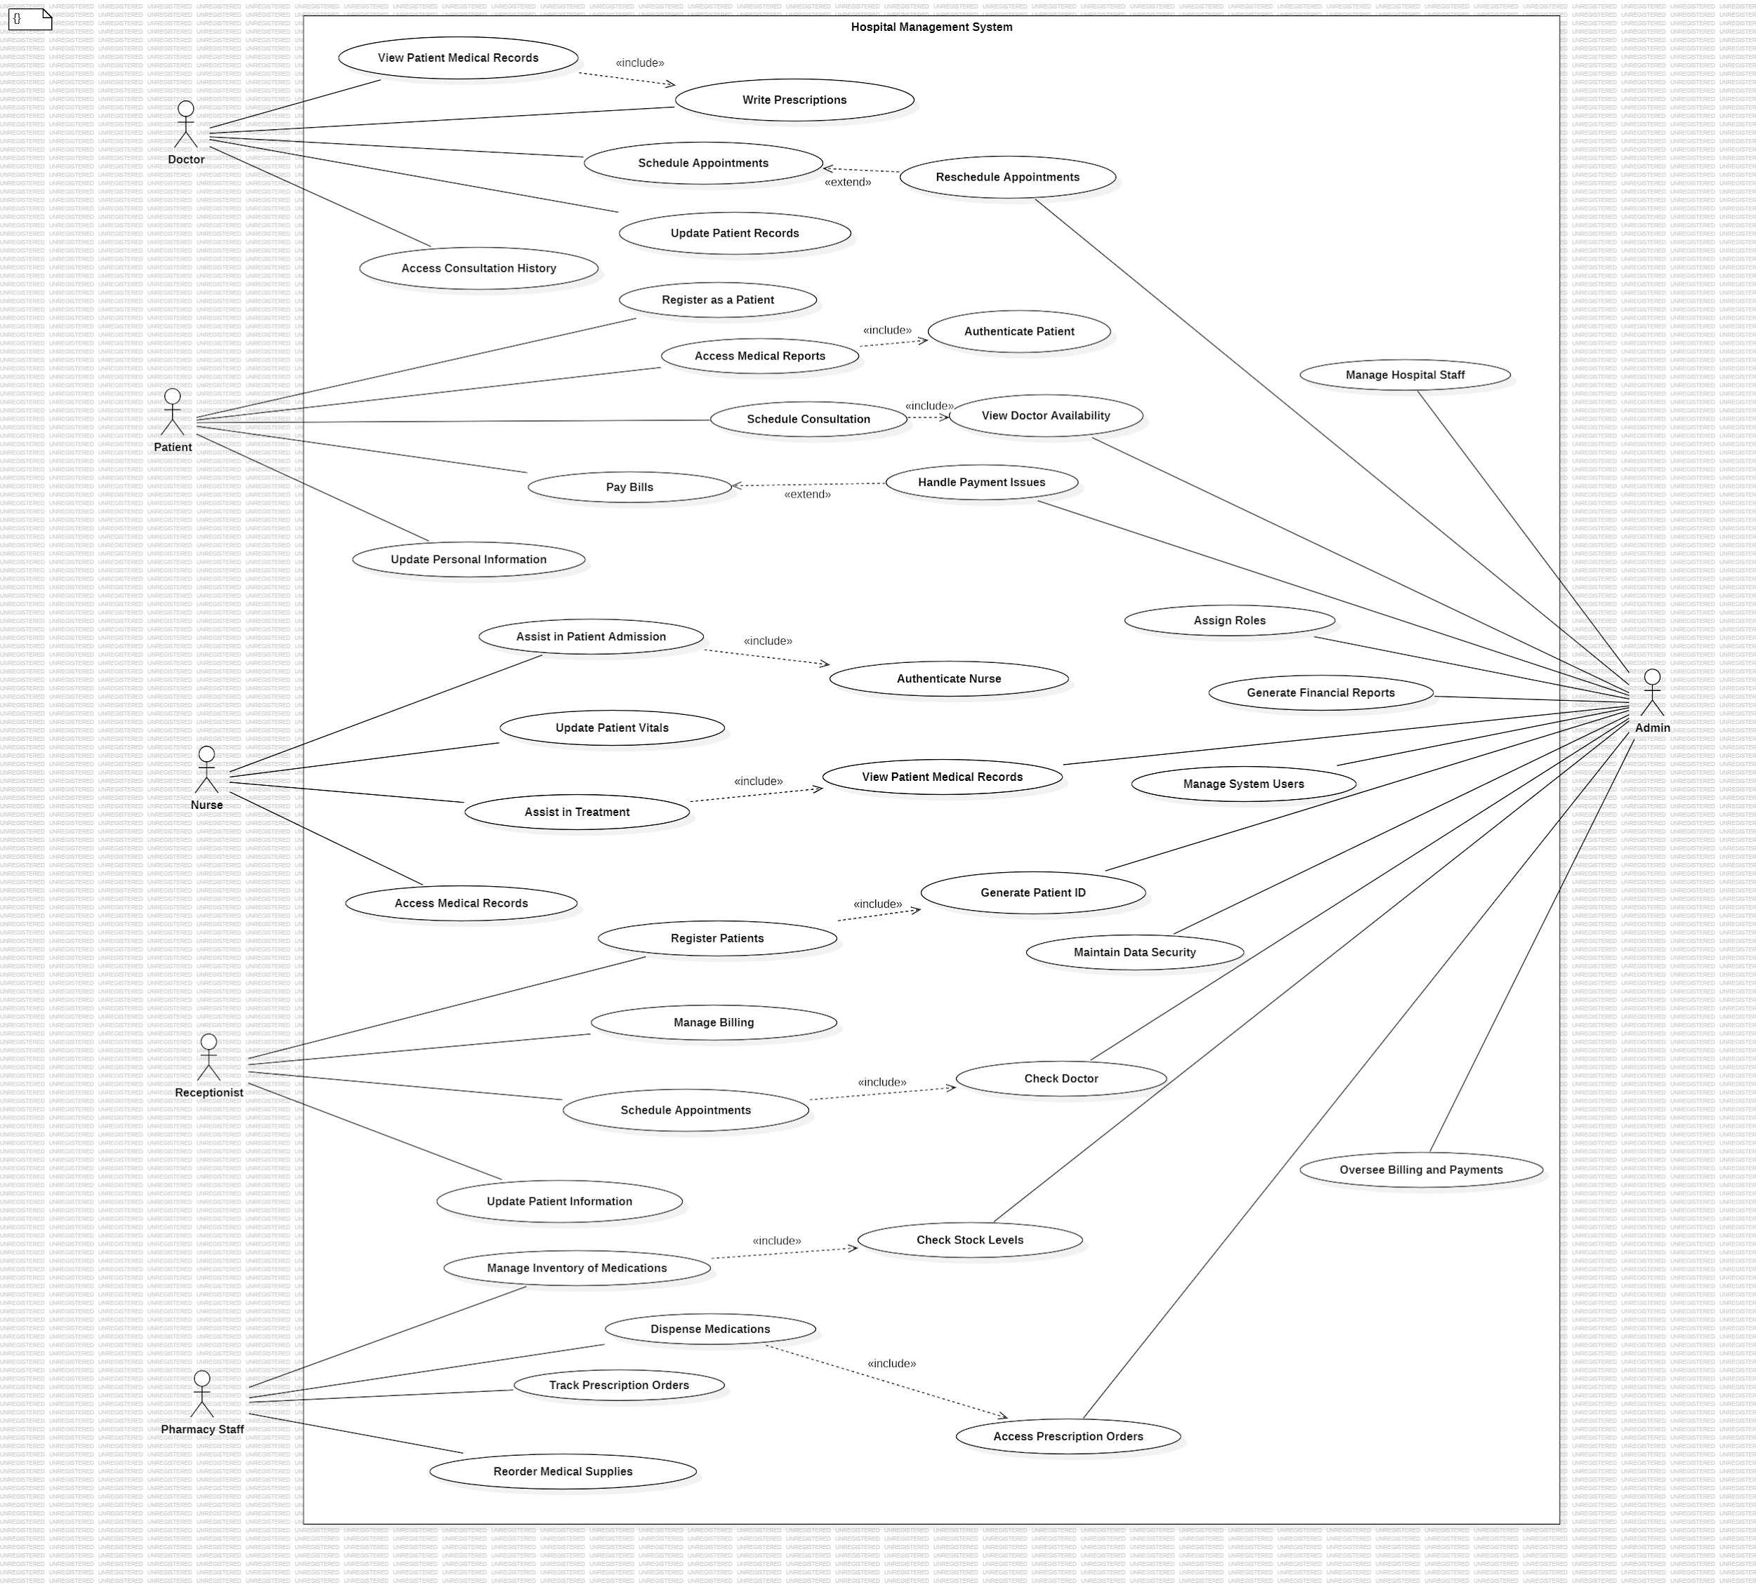

**Class Diagram**

**Sequence Diagram:**

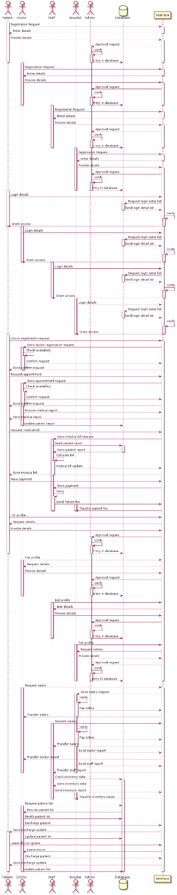

**Component Diagram:**

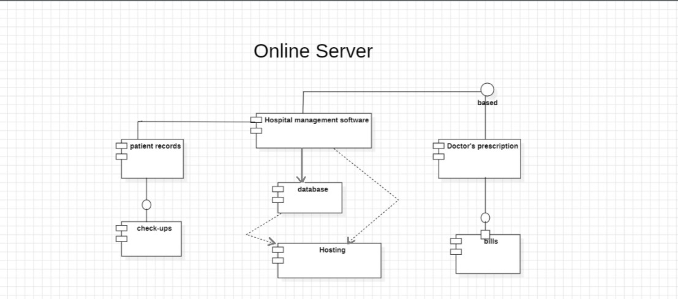

**Appendix C: To Be Determined List**

* Specific third-party lab systems to be integrated.
* Finalized user roles and permissions for different staff members (doctors, nurses, administrative staff, etc.).
* Detailed performance metrics and benchmarks to evaluate system efficiency during peak hours.

**Result:** Prepared SRS document, designed document and tested phase related documents.